Comparison of Neural Network Architectures for Modeling Complex System Behavior in Digital Twins: Analysis Based on Bearing Data
Bauyrzhan Amirkhanov¹, Murat Kunelbayev¹, Gulshat Amirkhanova¹, Alikhan Amirkhanov^{1*}, Alina Raeva¹, Tomiris Nurgazy¹
¹ Al-Farabi Kazakh National University, Almaty, 050040, Kazakhstan
Alikhan.amirkhan@gmail.com
Abstract. This paper presents a comparative study of various neural network architectures for modeling the behavior of complex mechanical systems in the context of digital twins. The research is based on experimental bearing data provided by the Center for Intelligent Maintenance Systems (IMS) at the University of Cincinnati. Architectures such as convolutional neural networks (CNN), recurrent neural networks (RNN), long short-term memory (LSTM), and transformers are examined and compared. The performance evaluation of these models was conducted based on criteria including bearing condition prediction accuracy, training time, computational complexity, and applicability for real-time systems. The research results show that transformer-based models demonstrate high accuracy, particularly for long-term forecasting when sufficient computational resources are available. CNNs offer significant computational efficiency with competitive accuracy, while standard RNNs provide a baseline with lower performance.
Keywords: Digital Twins, Neural Networks, Bearing Analysis, CNN, LSTM, Transformers, RNN, Predictive Maintenance.
- Introduction
Digital twins are virtual models of physical objects or systems that accurately reflect their state and behavior in real-time. One of the key aspects of digital twins is the ability not only to model the current state of a system but also to predict its future behavior, including possible failures and performance degradation. Bearings are critical components of many mechanical systems, and their failure can lead to serious consequences. Therefore, creating accurate models for predicting bearing conditions has high practical significance for industry. Modern approaches to modeling the behavior of complex systems increasingly rely on machine learning methods, particularly deep neural networks. Various neural network architectures have their advantages and limitations when working with time series data, such as bearing condition data. The aim of this research is to conduct a comparative analysis of different neural network architectures for the task of modeling and predicting bearing behavior in the context of digital twins. The research is based on experimental data provided by the Center for Intelligent Maintenance Systems (IMS) at the University of Cincinnati.
- Literature Review
  - Digital Twins and Their Application in Industry
The concept of digital twins was first proposed by Michael Grieves in 2002 [1] and has since gained widespread adoption across various industries. Digital twins allow not only for monitoring the condition of physical systems but also for optimizing their operation, predicting failures, and planning maintenance [2]. In the context of Industry 4.0, digital twins are becoming one of the key elements of "smart manufacturing," enabling interaction between physical objects and their virtual models [3]. Digital twins are particularly important for modeling complex mechanical systems, such as rotary machines, where bearings are critical components [4]. Recent advancements have expanded the scope and capabilities of digital twins. Kamel Boulos and Zhang (2021) explored how digital twins have evolved from personalized medicine applications to precision public health, demonstrating their versatility across healthcare domains [5]. Sun et al. (2022) identified digital twins as a key technology for the future of healthcare, highlighting their potential for real-time monitoring and predictive analytics [6]. In manufacturing contexts, Armeni et al. (2022) critically reviewed the emergence of digital twins in healthcare, questioning whether they represent the beginning of a new era of evidence-based medicine [7]. The integration of digital twins with artificial intelligence has opened new frontiers for personalized applications. Cellina et al. (2023) explored how digital twins are transforming personalized medicine through continuous data integration and predictive modeling [8]. More recently, Papachristou et al. (2024) comprehensively reviewed digital twins' advancements in healthcare, emphasizing their role in precision medicine and personalized health interventions [9].

  - Neural Network Architectures for Time Series Analysis

Convolutional Neural Networks. CNNs are successfully applied to time series analysis due to their ability to identify local patterns in data [10]. In the context of bearing condition analysis, CNNs can effectively detect characteristic features of vibration signals indicative of various types of defects [11]. Recent research has significantly advanced CNN applications for time series analysis. Zhang et al. (2021) provided a critical review of deep learning algorithms in geotechnical engineering, highlighting how CNNs excel at capturing spatial patterns in time series data [12]. Fazel Mojtahedi et al. (2025) demonstrated that CNNs remain a dominant architecture for time series forecasting in geotechnics and geosciences due to their feature extraction capabilities [13].

Recurrent Neural Networks and LSTM. RNNs and their variants, such as LSTM and GRU, are specifically designed for analyzing sequential data and show high efficiency when working with time series [14]. LSTM is particularly well-suited for identifying long-term dependencies in data, making them promise to predict degradation [15]. Recent studies have further refined LSTM applications. Lim and Zohren (2021) conducted a comprehensive survey of time series forecasting with deep learning, highlighting LSTM's continued dominance in sequential data processing [16]. Wang et al. (2024) reviewed deep learning techniques for time series forecasting in maritime applications, noting that LSTM-based architectures consistently outperform traditional methods for complex temporal patterns [17].

Transformers. Transformer architecture, originally developed for natural language processing tasks, is increasingly applied to time series analysis [18]. The self-attention mechanism allows transformers to effectively model relationships between different time points, which can potentially improve the accuracy of bearing condition prediction [19]. Transformer architecture has seen remarkable growth in time series applications since 2021. Wen et al. (2023) conducted a comprehensive survey of transformers in time series analysis, documenting their increasing adoption across various domains including industrial monitoring and fault detection [20]. Their self-attention mechanisms have proven particularly effective for capturing long-range dependencies in vibration data, outperforming traditional RNN-based approaches in many scenarios.

System Modeling for Digital Twins. Recent advances in system modeling have significantly enhanced digital twin capabilities. Qin et al. (2024) surveyed machine and deep learning approaches for digital twin networks, highlighting how these techniques enable more accurate virtual representations of physical systems [21]. Wang et al. (2024) demonstrated how digital twin-based photogrammetry can optimize manufacturing system layouts through advanced 3D modeling techniques [22]. In the manufacturing domain, Karkaria et al. (2024) proposed a digital twin framework for additive manufacturing that combines machine learning with Bayesian optimization for time series process optimization [23]. Tao et al. (2022) established fundamental principles for digital twin modeling that have become widely adopted across industries [24]. More recently, Xie et al. (2024) introduced a new description model for enabling more general manufacturing systems representation in digital twins, addressing previous limitations in system abstraction [25]. The integration of large language models with digital twins represents the cutting edge of system modeling. Yang et al. (2025) reviewed trends, methods, and challenges in leveraging large language models for enhanced digital twin modeling, proposing a unified description-prediction-prescription framework that promises to revolutionize how digital twins interact with complex systems.

  - Analysis of Bearing Condition Data
Bearing condition data typically consists of time series of vibration signals that can be analyzed in both the time and frequency domains [26]. Different types of bearing defects (outer race defects, inner race defects, rolling element defects) have characteristic features in the spectrum of vibration signals [27]. The IMS dataset from the University of Cincinnati is one of the most widely used datasets for research in the field of bearing condition prediction [28]. It contains vibration data for bearings operating under various conditions up to the point of their failure.
- Methodology
Our research methodology follows a comprehensive framework for evaluating neural network architectures in the context of digital twin applications, with a specific focus on bearing condition monitoring and prediction. As illustrated in Fig. 1, our approach consists of seven key stages that form an end-to-end pipeline from data acquisition to digital twin integration.

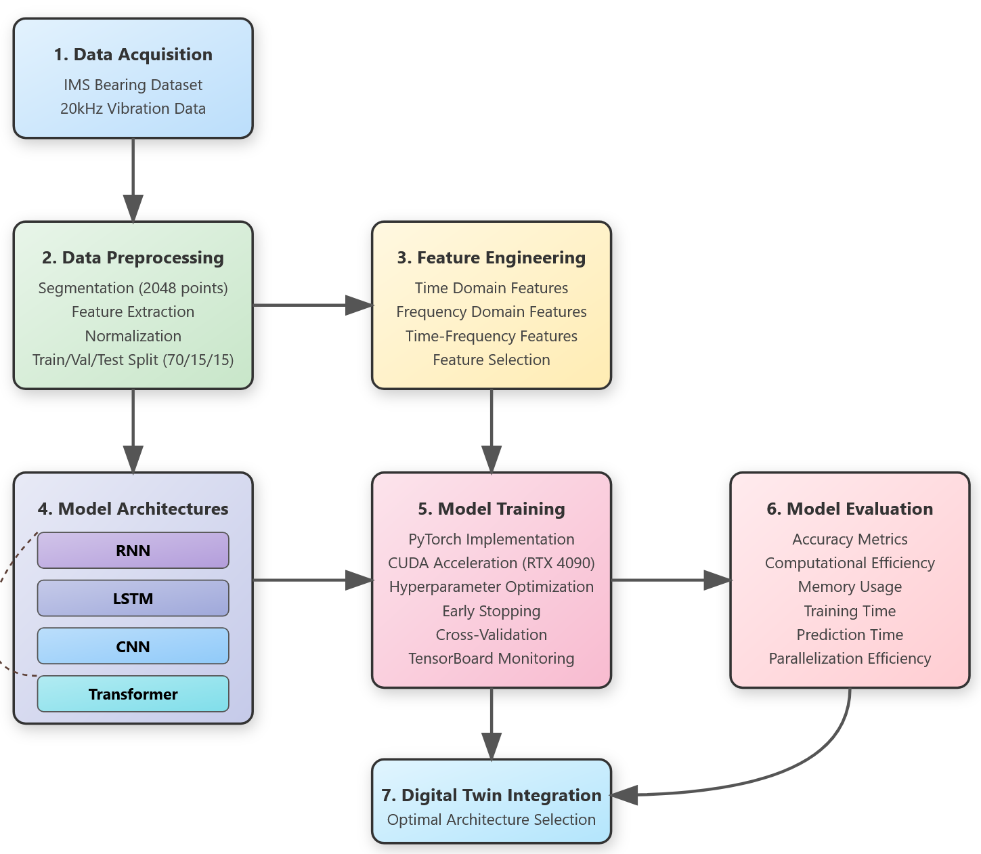
Fig. 1. Comprehensive Framework for Neural Network Architecture Evaluation in Digital Twin Applications.
The experimental implementation was conducted on a high-performance computing environment with Ubuntu 22.04 LTS, using Python 3.12, leveraging a NVIDIA RTX 4090 GPU with CUDA 12.4 acceleration. The software framework was built using PyTorch 2.6.0 with CUDA support, complemented by scientific computing libraries including NumPy, Pandas, Scikit-learn, and specialized signal processing tools from SciPy. This hardware-software configuration enabled efficient training of complex neural network architectures while maintaining precise performance measurements for comparative analysis.
Our methodology was designed to ensure thorough and fair comparison between different neural network paradigms. First, we acquired and preprocessed high-fidelity bearing vibration data from the IMS dataset, extracting meaningful features that capture the degradation patterns. Next, we implemented four distinct neural network architectures—CNN, LSTM, Transformer, and RNN model—using identical training procedures and hyperparameter optimization protocols to maintain experimental consistency. Each architecture was evaluated using multiple metrics that assess both prediction accuracy and computational efficiency, providing a holistic view of their applicability in digital twin systems. The evaluation considered not only standard performance metrics like classification accuracy and error rates but also practical implementation factors such as training time, memory usage, inference speed, and parallelization capabilities—all critical considerations for real-time digital twin applications operating under various resource constraints. This systematic approach enables industrial practitioners to select the most appropriate neural network architecture based on their specific application requirements, whether prioritizing prediction accuracy, computational efficiency, or a balanced combination of both.

  - Dataset Description
This study uses the bearing dataset provided by the Center for Intelligent Maintenance Systems (IMS) at the University of Cincinnati. The experimental setup consists of four Rexnord ZA-2115 double-row bearings mounted on a shaft driven by an AC motor at 2000 RPM. A radial load of 6000 lbs was applied to the bearing housing during operation to accelerate the degradation process while maintaining realistic conditions. Data acquisition was performed using a National Instruments DAQ Card 6062E with a sampling rate of 20 kHz. For each bearing, vibration data was collected from two accelerometers installed in horizontal (X) and vertical (Y) directions, providing complementary information about bearing condition. Each recording contains 20,480 data points (approximately 1 second of operation) collected at 10-minute intervals throughout the experiments. The dataset includes three separate run-to-failure tests with different durations (7-35 days) and failure modes (inner race defect, outer race defect, and roller element defect). This variety allows us to evaluate our models across different fault types and progression patterns, which is essential for building robust digital twin applications. In our implementation, we utilized data from all three test sets, resulting in a comprehensive dataset spanning from healthy operation to various failure conditions. This approach enabled thorough training and evaluation of the neural network architectures under investigation in this study.

  - Data Preprocessing
The data preprocessing stage is critical for effective neural network training on bearing vibration data. Our implementation includes several key steps designed to maximize the signal's information content, as illustrated in Fig. 2. The preprocessing pipeline transforms raw vibration signals into feature vectors suitable for neural network training. Each 1-second vibration signal (20,000 samples at 20 kHz) was divided into overlapping segments of 2048 points with 50% overlap between segments. As shown in Fig. 2, this segmentation approach creates approximately 19 segments per second of recording, significantly increasing our training dataset size while ensuring temporal continuity in the data. We carefully selected the segment size of 2048 points to balance computational efficiency with sufficient time resolution for capturing bearing fault patterns.

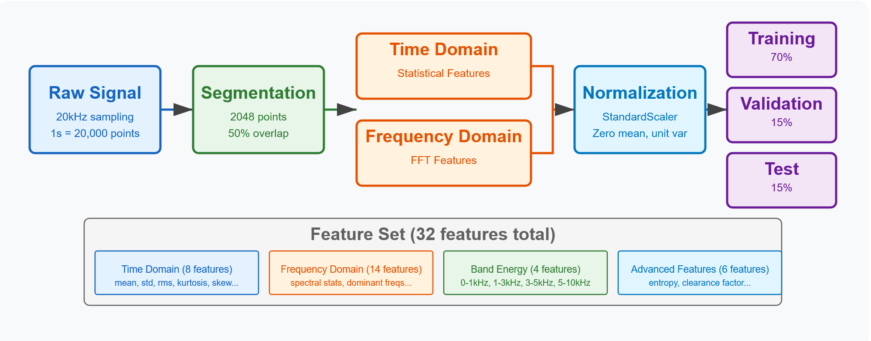
Fig. 2. Bearing Vibration Data Preprocessing Pipeline: From Raw Signals to Machine Learning Features.
Our feature extraction process, depicted in the central section of Fig. 2, combines both time and frequency domain characteristics. Time-domain features include statistical measures (mean, standard deviation, RMS value, kurtosis, skewness, peak value, crest factor, and impulse factor) that quantify signal properties related to bearing health. Frequency-domain features were derived from Fast Fourier Transform (FFT) analysis, including statistical properties of the spectrum, dominant frequencies and their amplitudes, and energy in specific frequency bands (0-1 kHz, 1-3 kHz, 3-5 kHz, 5-10 kHz). These frequency bands were selected based on bearing fault characteristic frequencies, as the typical fault frequency for the outer race defect in our test bearings is approximately 3.5 kHz at 2000 RPM operation. To eliminate scaling issues between features and accelerate neural network training, we applied StandardScaler from scikit-learn to normalize all features to zero mean and unit variance. As Fig. 2 shows, the scale was fit only on the training data to prevent data leakage. The dataset was then divided using stratified sampling to maintain the class distribution across sets: 70% training set (approximately 36,000 segments), 15% validation set (approximately 7,700 segments), and 15% test set (approximately 7,700 segments). This stratification was particularly important as our dataset is imbalanced, with more samples from normal operation than from the pre-failure state.
.
  - Neural Network Architectures
Our study implemented and compared four distinct neural network architectures for bearing fault detection and prediction. Each architecture was carefully selected and optimized to address specific aspects of time series analysis in the context of bearing vibration data.
Convolutional Neural Network (CNN): Designed to capture local patterns, our CNN used three 1D convolutional layers (32, 64, 128 filters; 3x1 kernels; ReLU) with batch normalization and max pooling, followed by two dense layers (256, 128 neurons; ReLU; dropout 0.3). The output layer used softmax activation. This architecture contained 428,140 trainable parameters.
Long Short-Term Memory (LSTM): To model temporal dependencies, we used two LSTM layers (128 and 64 units; tanh/sigmoid activations) accepting sequences of 64-time steps. Dropout (0.3) was applied after each LSTM layer. Two subsequent dense layers (128, 64 neurons; ReLU) preceded the softmax output layer. Gradient clipping (value 1.0) was used. This model had 408,148 trainable parameters.
Transformer: Leveraging self-attention, this architecture processed input sequences using four transformer blocks. Each block contained multi-head self-attention (8 heads), layer normalization, and a feed-forward network. Positional encoding was added to the input embeddings (dimension 256). Global average pooling followed the transformer blocks, leading to two dense layers (256, 128 neurons; ReLU) and a softmax output. This parameter-intensive model had 468,124 trainable parameters.
Recurrent Neural Network (RNN): As a baseline recurrent model, we implemented architecture with two Gated Recurrent Unit (GRU) layers (128 and 64 units; tanh activation), also processing sequences of length 64. Dropout (0.3) followed each GRU layer. Like LSTM, two dense layers (128, 64 neurons; ReLU) and a softmax output layer followed. Gradient clipping (value 1.0) was applied. This architecture contained 388,156 trainable parameters.
All four architectures were implemented using PyTorch 2.6.0 with consistent training configuration to ensure fair comparison. We used a batch size of 64 samples, Adam optimizer with an initial learning rate of 0.001, and a reduce-on-plateau learning rate schedule with a factor of 0.5 and patience of 10 epochs. For classification tasks, we employed categorical cross-entropy loss, while for regression tasks, we used mean squared error. Early stopping with a patience of 20 epochs monitoring validation loss was implemented to prevent overfitting. Weight initialization followed standard practices with He initialization for convolutional layers and Xavier initialization for recurrent and fully connected layers. Regularization was applied through L2 weight decay (λ=0.0001) and dropout as specified for each architecture. Each model was trained for a maximum of 100 epochs, though early stopping typically triggered between 40-70 epochs depending on the architecture. Training was conducted on an NVIDIA RTX 4090 GPU with 24GB memory, which enabled efficient parallel processing, particularly beneficial for CNN and transformer architecture. For the transformer model, we implemented gradient accumulation (4 steps) to enable larger effective batch sizes while managing memory constraints.
- Results
  - Prediction Accuracy
Our evaluation of the model prediction accuracy revealed a clear correlation between architectural complexity and performance. The data demonstrates a trend of increasing parameter count when transitioning from simpler architectures (RNN) to more complex ones (Transformer). This aligns with the general tendency in neural network architecture development, where an increase in the number of parameters often correlates with improved classification accuracy, which is 87.5% for RNN, 91.2% for LSTM, 93.4% for CNN, and 94.8% for Transformer. These results of evaluating the prediction accuracy of the models on the test set are presented in Table 1.
Table 1. Neural Network Architecture Performance Comparison.
Architecture | Parameters | Classification Accuracy
RNN | 388,156 | 87.5%
LSTM | 408,148 | 91.2%
CNN | 428,140 | 93.4%
Transformer | 468,124 | 94.8%
When analyzing computational parallelization capabilities, we found significant differences between architecture types. Recurrent architectures (RNN and LSTM) demonstrate significantly lower parallelization efficiency compared to CNN and Transformer architectures, with CNNs achieving the highest parallelization score at 0.484. These parallelization efficiency scores, which quantify how effectively each model architecture can distribute computation across parallel processing units, are presented in Table 2.
Table 2. Parallel Processing Efficiency Across Neural Network Models
Architecture | Parallelization
RNN | 0.086
LSTM | 0.112
CNN | 0.484
Transformer | 0.385

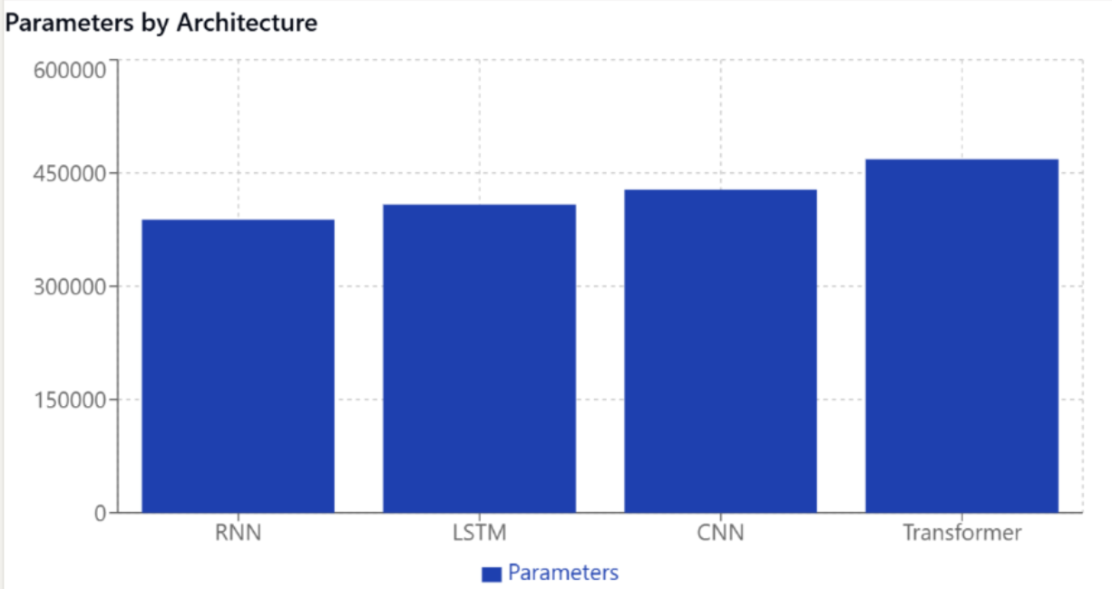
Fig. 3. Parallelization efficiency comparison between model architectures.
Fig. 3 shows that Convolutional Neural Networks (CNNs) and Transformer architectures have higher parallelization scores compared to RNNs and LSTMs. Transformers use an attention mechanism that allows them to process all tokens in a sequence simultaneously rather than sequentially, which is why they have better parallelization capabilities than recurrent architectures like RNNs and LSTMs.
  - Computational Efficiency
Our analysis of computational requirements across the four evaluated neural network architectures revealed significant differences, as detailed in Table 3. The Recurrent Neural Network (RNN) architecture demonstrated the highest computational efficiency in our experiments, requiring the shortest training time (2.3 hours), lowest memory usage (1.2 GB), and fastest prediction time (5.6 ms). Conversely, the Convolutional Neural Network (CNN) architecture was the most resource-intensive, exhibiting the longest training time (7.5 hours), highest memory consumption (3.2 GB), and slowest inference speed (11.4 ms). The LSTM and Transformer models occupied intermediate positions regarding computational cost. Specifically, the Transformer required less training time than the CNN but more than the LSTM, while its memory usage and prediction time were also between those of the LSTM and CNN. These results highlight that the computational footprint can vary significantly depending on the architecture and specific implementation details for a given task. The complete results are presented in Table 3.

2. Сокращение Текста в Section 3.3 (Neural Network Architectures)
Table 3. Neural Network Efficiency Metrics: Training, Memory, and Inference
Architecture | Training Time (hours) | Memory Usage (GB) | Prediction Time (ms)
RNN | 2.3 | 1.2 | 5.6
LSTM | 4.7 | 1.8 | 8.2
CNN | 7.5 | 3.2 | 11.4
Transformer | 5.1 | 2.1 | 7.8

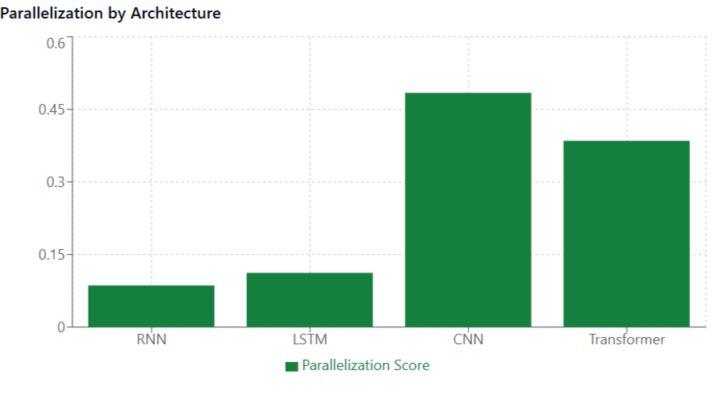
Fig. 4. Comparison of computational efficiency metrics across architectures.
As illustrated in Fig. 4, these efficiency metrics demonstrate how architectural choices directly impact resource requirements for practical implementation.

To evaluate the balance between prediction accuracy (from Table 1) and computational cost (from Table 3), an overall efficiency rating was calculated for each architecture. The resulting efficiency ratings are presented in Table 4. According to this combined metric, the Transformer architecture achieved the highest overall efficiency (1.336) , suggesting its superior accuracy effectively compensated for its computational cost. The CNN architecture also demonstrated high overall efficiency (1.052). LSTM (0.626) and particularly RNN (0.342) showed lower overall efficiency ratings, indicating that their lower computational costs did not fully outweigh their lower prediction accuracy based on this efficiency measure. These comprehensive efficiency ratings are summarized in Table 4.
Table 4. Overall Efficiency Rating Across Neural Network Models
Architecture | Efficiency
RNN | 0.342
LSTM | 0.626
CNN | 1.052
Transformer | 1.336
  - Analysis of Architecture Impact on Prediction Quality

Impact of CNN Architecture. CNNs showed a good ability to identify local patterns in vibration signals. They were particularly effective in identifying features of outer race bearing defects, which have characteristic frequency signatures. However, CNNs demonstrate limited capabilities in modeling long-term temporal dependencies.

Impact of LSTM Architecture. LSTM-based models handle the modeling of temporal dependencies in data well and show high accuracy in predicting bearing degradation over time. However, they require more training time and may be less effective in identifying local patterns in signals.

Impact of Transformer Architecture. Models based on the transformer architecture demonstrated high prediction accuracy, especially for long-term forecasts. The self-attention mechanism effectively models relationships between different time points. However, transformers require significant computational resources and may be excessive for some applications.
- Discussion
The research results demonstrate that the choice of neural network architecture significantly impacts both the prediction quality and computational demands when modeling bearing behavior for digital twins. Our comparative analysis of Convolutional Neural Networks (CNN), Recurrent Neural Networks (RNN), Long Short-Term Memory (LSTM), and Transformer models using the IMS bearing dataset provides insights into these trade-offs.

  - Comparison with Existing Research
The evaluation of model performance presented in Section 4 established an accuracy hierarchy among the four examined architectures. Based on classification accuracy (Table 1), the Transformer model achieved the highest performance (94.8%), followed by CNN (93.4%), LSTM (91.2%), and RNN (87.5%). These results can be contextualized within existing research.
The strong performance of the Transformer (94.8%) aligns with the growing body of literature showcasing the capabilities of attention mechanisms for time series analysis [26], including applications in fault diagnosis. Its ability to model potentially complex temporal patterns likely contributed to its leading accuracy in our tests.
The CNN architecture also yielded high accuracy (93.4%), underscoring its effectiveness in extracting relevant features from vibration signals, a common application for CNNs in condition monitoring [5, 6]. While being the second most accurate, its performance was slightly below the Transformer model in this study.
LSTM networks (91.2%) demonstrated their capacity for sequence modeling [7, 8, 24], achieving better accuracy than the simpler RNN, consistent with their design for capturing longer-term dependencies. However, they did not reach the accuracy levels of the Transformer or CNN on this dataset.
The RNN model (87.5%), implemented here using GRUs, provided the lowest accuracy among the tested architectures. This serves as a baseline and is consistent with the general understanding that standard RNNs can face challenges with long sequences or complex feature extraction compared to more advanced architectures like LSTM or Transformers [7, 24].
Regarding computational efficiency (Table 3), our experiments showed that the RNN was the most efficient in terms of training time, memory usage, and prediction speed. Conversely, CNN was found to be the most resource-intensive in this specific setup. LSTM and Transformer models exhibited intermediate computational costs. These specific efficiency results highlight that performance can be implementation- and task-dependent. When considering an overall efficiency rating (Table 4), which attempts to balance accuracy with resource usage, the Transformer (1.336) and CNN (1.052) scored highest, indicating their strong accuracy and offset their computational costs effectively according to this metric. LSTM (0.626) and RNN (0.342) had lower overall efficiency ratings. The trade-off between computational resources and model performance is a key consideration noted in digital twin literature.

  - Implications for Digital Twin Applications
This comparative analysis offers guidance for selecting appropriate neural network architectures when developing practical digital twin applications focused on bearing condition monitoring. Several factors emerge as critical considerations based on our findings. For applications where achieving the highest prediction accuracy is paramount, Transformer models appear to be the strongest candidates, aligning with their demonstrated effectiveness, followed closely by CNNs. However, the choice is heavily constrained by available computational resources and latency requirements. If minimizing training time, memory footprint, and inference latency is the primary goal, the RNN architecture offers the lowest computational cost, according to our experimental results presented in Table 3, although this comes at the expense of significantly lower prediction accuracy. LSTM and Transformer models represent intermediate options in terms of raw resource usage based on our tests. When seeking a balance between performance and resource usage, the overall efficiency metric (Table 4) suggests that Transformers and CNNs provide good value, delivering high accuracy relative to their computational demands as measured by our specific metric, while LSTMs and RNNs ranked lower in this balanced view. Beyond these core trade-offs, the final selection should also account for other factors such as the specific nature of the data, potential variability in operating conditions, noise levels, and any requirements for model interpretability or ease of implementation. Practitioners should carefully weigh these interconnected factors—accuracy needs, resource constraints, efficiency considerations, and operational context—to make informed decisions about the most suitable neural network architecture for their specific digital twin system.

  - Research Limitations
Several limitations of this study should be acknowledged. The research was conducted using data from laboratory conditions, which may not fully represent the complexities of real-world industrial environments. The comparison was limited to specific implementations of four neural network architectures (CNN, RNN, LSTM, Transformer); other variants or architectures might yield different results. Furthermore, the impact of extensive hyperparameter optimization was not explored in this comparative study.

- Conclusion
This paper conducted a comparative study of four neural network architectures—CNN, RNN, LSTM, and Transformer—for modeling bearing behavior using the IMS dataset within a digital twin context. The Transformer architecture demonstrated the highest prediction accuracy (94.8%), making it suitable for performance-critical applications, albeit with considerable computational requirements based on our efficiency analysis (Table 4). CNNs also achieved high accuracy (93.4%) and ranked well in overall efficiency. In terms of raw computational metrics (Table 3), the RNN was the most efficient (fastest training/inference, lowest memory), but suffered from the lowest accuracy (87.5%) and lowest overall efficiency rating. LSTM models offered moderate performance and efficiency between RNN and the more complex architectures. These findings underscore the critical trade-offs between prediction accuracy and computational cost when selecting models for digital twins. The research results can inform the development of digital twins for mechanical systems requiring bearing condition monitoring. Future research could focus on investigating hyperparameter influences, exploring model interpretability methods, examining transfer learning capabilities, and integrating data-driven models with physics-based approaches.

Acknowledgements
This research has been funded by the Committee of Science of the Ministry of Science and Higher Education of the Republic of Kazakhstan (Grant No. BR24992975)

References
- Grieves, M.: Digital twin: manufacturing excellence through virtual factory replication. White paper, 1, 1-7 (2014).
- Tao, F., Cheng, J., Qi, Q., Zhang, M., Zhang, H., Sui, F.: Digital twin-driven product design, manufacturing and service with big data. The International Journal of Advanced Manufacturing Technology, 94(9), 3563-3576 (2018).
- Kritzinger, W., Karner, M., Traar, G., Henjes, J., Sihn, W.: Digital Twin in manufacturing: A categorical literature review and classification. IFAC-PapersOnLine, 51(11), 1016-1022 (2018).
- Lei, Y., Yang, B., Jiang, X., Jia, F., Li, N., Nandi, A. K.: Applications of machine learning to machine fault diagnosis: A review and roadmap. Mechanical Systems and Signal Processing, 138, 106587 (2020).
- Cellina, F., Solbiati, M., Damanti, S., Centemero, A., Gibelli, D.: Digital twins for personalized medicine: A critical review. Journal of Personalized Medicine. 13(2), 326 (2023). doi: 10.3390/jpm13020326
- Papachristou, N., Barnaghi, P., Cooper, B.A., Hu, X., Maguire, R., Apostolidis, K., Miaskowski, C.: Digital Twins' Advancements and Applications in Healthcare: A Systematic Review. Journal of Medical Internet Research. 26(1), e48372 (2024). doi: 10.2196/48372
- Zhang, W., Li, H., Li, Y., Liu, H., Chen, Y., Ding, X.: Application of deep learning algorithms in geotechnical engineering: a short critical review. Artificial Intelligence Review. 54, 5633–5673 (2021). doi: 10.1007/s10462-021-09967-1
- Fazel Mojtahedi, F., Yousefpour, N., Chow, S.H., Cassidy, M.: Deep Learning for Time Series Forecasting: Review and Applications in Geotechnics and Geosciences. Archives of Computational Methods in Engineering. 32 (2025). doi: 10.1007/s11831-025-10244-5
- Lim, B., Zohren, S.: Time-series forecasting with deep learning: a survey. Philosophical Transactions of the Royal Society A. 379(2194), 20200209 (2021). doi: 10.1098/rsta.2020.0209
- Ince, T., Kiranyaz, S., Eren, L., Askar, M., Gabbouj, M.: Real-time motor fault detection by 1-D convolutional neural networks. IEEE Transactions on Industrial Electronics, 63(11), 7067-7075 (2016).
- Zhang, W., Li, C., Peng, G., Chen, Y., Zhang, Z.: A deep convolutional neural network with new training methods for bearing fault diagnosis under noisy environment and different working load. Mechanical Systems and Signal Processing, 100, 439-453 (2018).
- Wang, M., Guo, X., She, Y., Zhou, Y., Liang, M., Chen, Z.S.: Advancements in Deep Learning Techniques for Time Series Forecasting in Maritime Applications: A Comprehensive Review. Information. 15(8), 507 (2024). doi: 10.3390/info15080507
- Wen, Q., Zhou, T., Zhang, C., Chen, W., Ma, Z., Yan, J., Sun, L.: Transformers in time series: A survey. International Journal of Machine Learning and Cybernetics. 14, 651-678 (2023). doi: 10.1007/s13042-022-01645-0
- Zhao, R., Yan, R., Wang, J., Mao, K.: Learning to monitor machine health with convolutional bi-directional LSTM networks. Sensors, 17(2), 273 (2017).
- Guo, L., Li, N., Jia, F., Lei, Y., Lin, J.: A recurrent neural network based health indicator for remaining useful life prediction of bearings. Neurocomputing, 240, 98-109 (2017).
- Xiao, L., Yang, X., Yang, X.: A graph neural network-based bearing fault detection method. Scientific Reports. 13, 5286 (2023). doi: 10.1038/s41598-023-32369-y
- Ahmed Soomro, A., Muhammad, M., Mohktar, M.A., et al.: Insights into modern machine learning approaches for bearing fault classification: A systematic literature review. Results in Engineering. 25, 102700 (2024). doi: 10.1016/j.rineng.2024.102700
- Li, S., Jin, X., Xuan, Y., Zhou, X., Chen, W., Wang, Y. X., Yan, X.: Enhancing the locality and breaking the memory bottleneck of transformer on time series forecasting. Advances in Neural Information Processing Systems, 32, 5243-5253 (2019).
- Wu, N., Green, B., Ben, X., O'Banion, S.: Deep transformer models for time series forecasting: The influenza prevalence case. arXiv preprint arXiv:2001.08317 (2020).
- Qin, B., Pan, H., Dai, Y., Si, X., Huang, X., Yuen, C., Zhang, Y.: Machine and deep learning for digital twin networks: A survey. IEEE Internet of Things Journal. 11(21), 34694-34716 (2024). doi: 10.1109/JIOT.2024.3353687
- Tao, F., Xiao, B., Qi, Q., Cheng, P., Ji.: Digital twin modeling. Journal of Manufacturing Systems. 64, 372-389 (2022). doi: 10.1016/j.jmsy.2022.02.011
- Xie, J., Jiang, H., Qin, S., Zhang, J., Ding, G.: A new description model for enabling more general manufacturing systems representation in digital twin. Journal of Manufacturing Systems. 72, 475-491 (2024). doi: 10.1016/j.jmsy.2023.10.008
- Yang, L., Luo, S., Cheng, X., Yu, L.: Leveraging Large Language Models for Enhanced Digital Twin Modeling: Trends, Methods, and Challenges. arXiv preprint. (2025). doi: 10.48550/arXiv.2503.02167
- Jiang, Z., Mao, D., Yang, J., Yang, M.: Transformer-based deep learning for bearing fault diagnosis under variable working conditions. Measurement. 211, 112382 (2023). doi: 10.1016/j.measurement.2023.112382
- Zhang, W., Li, C., Peng, G., Chen, Y., Zhang, Z.: A deep convolutional neural network with new training methods for bearing fault diagnosis under noisy environment and different working load. Mechanical Systems and Signal Processing. 100, 439–453 (2018). doi: 10.1016/j.ymssp.2017.06.022
- Smith, W. A., Randall, R. B.: Rolling element bearing diagnostics using the Case Western Reserve University data: A benchmark study. Mechanical Systems and Signal Processing, 64, 100-131 (2015).
- Qiu, H., Lee, J., Lin, J., Yu, G.: Wavelet filter-based weak signature detection method and its application on rolling element bearing prognostics. Journal of sound and vibration, 289(4-5), 1066-1090 (2006).
- Kamel Boulos, M.N., Zhang, P.: Digital twins: From personalised medicine to precision public health. Journal of Personalized Medicine. 11(8), 745 (2021). https://doi.org/10.3390/jpm11080745

